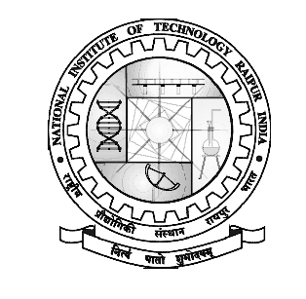 | DEPARTMENT OF SPORTS  NATIONAL INSTITUTE OF TECHNOLOGY RAIPUR  G. E. Road, Raipur, 492010 C. G  jk"Vªh; izkS|ksfxdhlaLFkkujk;iqj]  Tkh- bZ- jksM] jk;iqj] 492010 N-x-
 | Phone: (0771) 2255475, Fax: (0771) 2254600, Website: nitrr.ac.in

The Physical Education Center
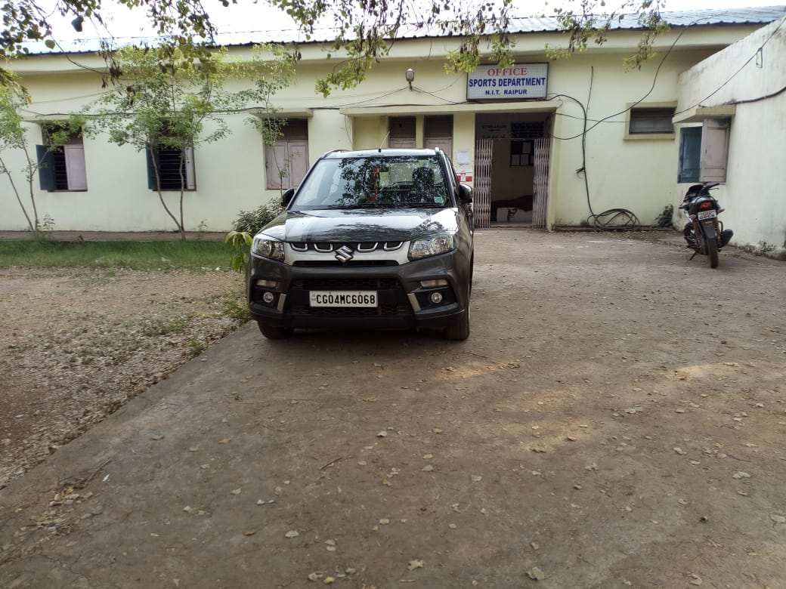

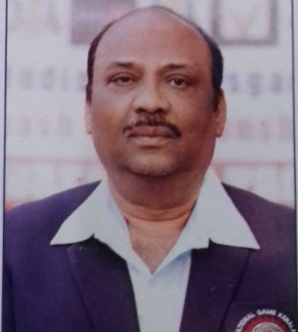

Dr. Alok Dubey
SAS Officer
Department of sports
NIT Raipur
Email:-akdubey.nit@gmail.com
Mob:-9424214850
The department provides and maintains the sports facilities required by the students and the staff.

The outdoor stadium has a 400M track. The cricket ground here hosts matches for the city league. The campus is dotted with one football grounds, one kho-kho court, one handball court, one hockey field, two volleyball courts, one basketball courts, one tennis courts and two badminton courts. Besides each hostel has separate playgrounds and indoor games such as table tennis and carroms

The Fitness Centre Which Also Has A Wooden Flooring Houses Many Exercise Machines Such As Multi-Station Gym, Tread Mill, Stairs, Rowing Machine, Exercycle And So On. These Are Used By The Students, Staff And Other Residents Of The Campus.

Activities of the Section include
Encouraging student participation in Inter-Year, Inter- Department, Inter-NIT and other open tournaments in the country.
Organizing Inter-Department tournaments (SAMAR), Inter-NIT coaching camps and open tournaments in various sports and games.
Organizing tournaments for Teaching and Non-Teaching staff.

Achievements
2018/2019
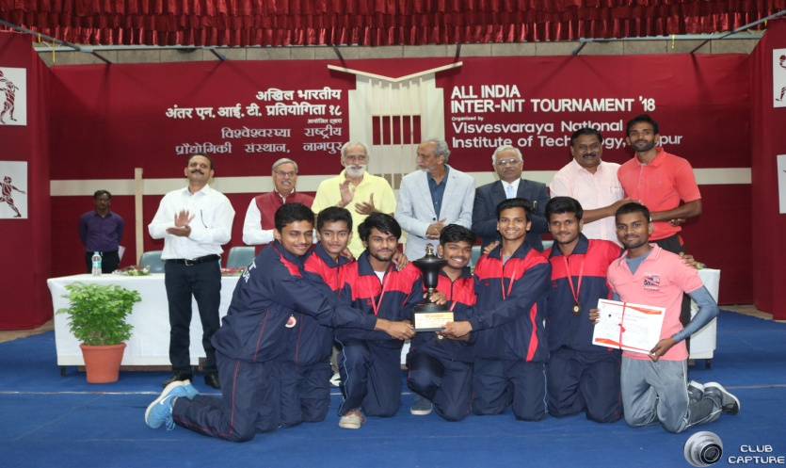 | All india inter nit tournament nit vnit Nagpur 28-9-18 to 2-10-18 boys yoga Gold medal
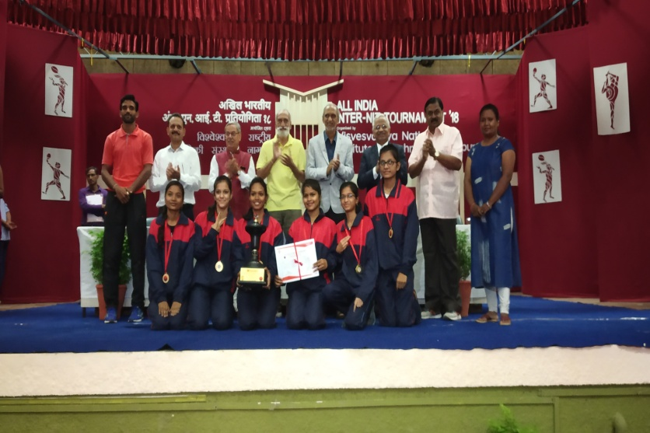 | All india inter nit tournament nit vnit Nagpur 28-9-18 to 2-10-18 girls yoga Gold medal
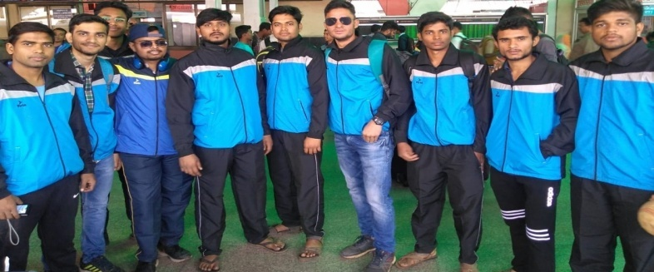 | All India Inter Nit Tournament Nit Surathkal 11-01-2018 to 14-01-2018  Boys Handball 2nd Runner up
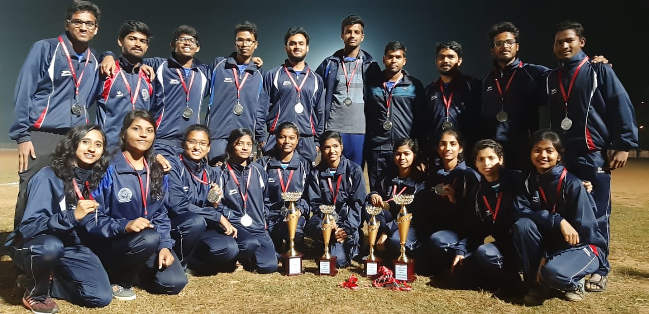 | All India Inter Nit Tournament Nit rourkela 25-01-2019 to 27-01-2019  Boys kho kho 1st Runner up  Girls kho kho 2nd runner up
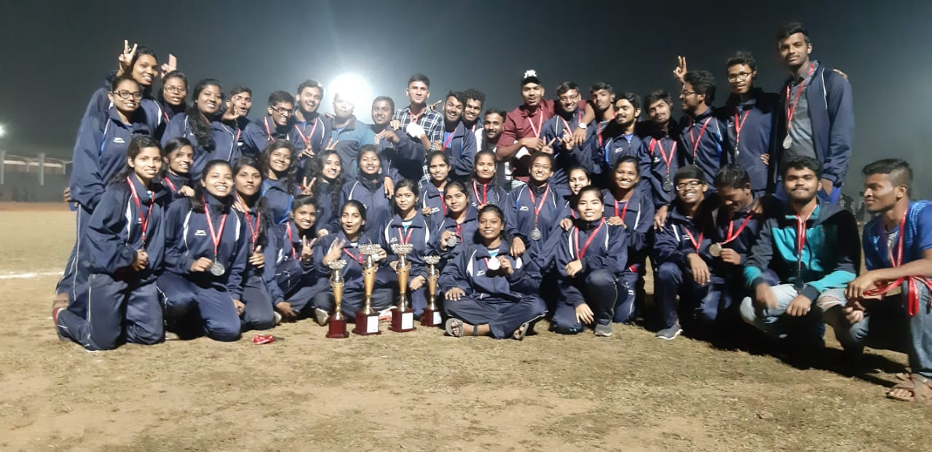 | All India Inter Nit Tournament Nit rourkela 25-01-2019 to 27-01-2019  Girls kabaddi 1st Runner up  Boys kabaddi 1st runner up
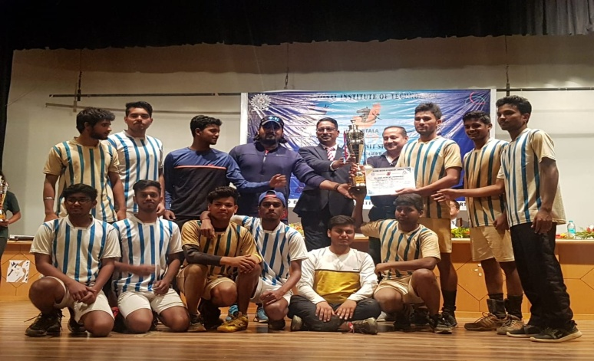 | All india inter nit tournament nit Agartala 07-03-2019 to 09-03-2019 handball boy’s 1st runner up

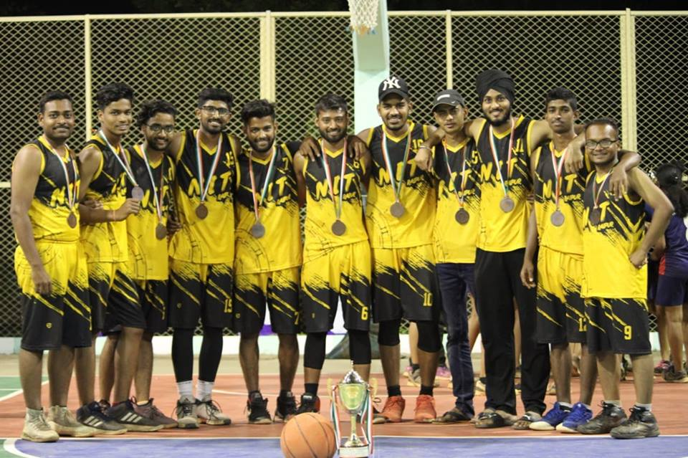 | All India Inter Nit Tournament Nit rourkela 20-02-2019 to 23-02-2019  Boys BASKETBALL 2nd runner up
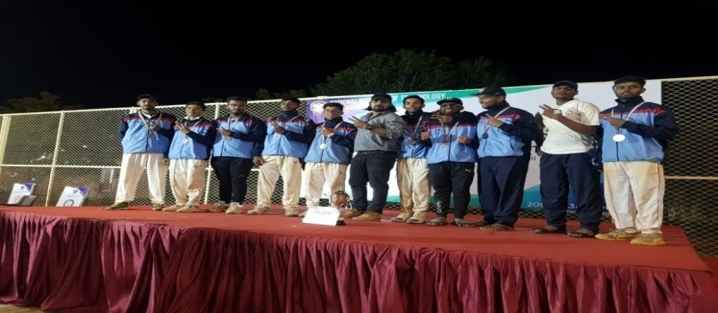 | All india inter nit tournament nit trichi 20/01/2019 cricket boy’s 2nd runner

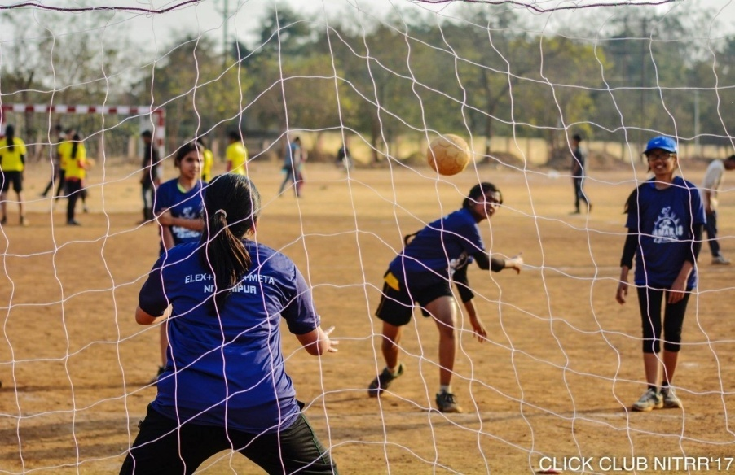 | SATART THE GAME OF SAMAR 2019

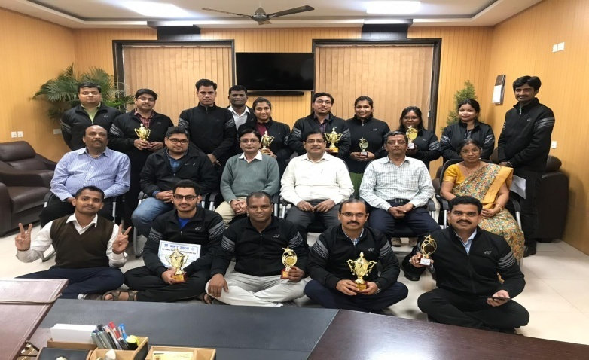 | All India Inter NIT FACULTY Tournament NIT GOA 7-12-2018 to 9-12-2018  TT WINNER  OVERALL 3RD POSITION

